Call for Sites Housing and Economic Land Availability Assessment (HELAA) 2020 - 2021
New Site Assessment Document
December 2025/ January 2026
Assessment Criteria
- Access
- Suitability
- Stream and surface water flooding issues
- Needs of rural village
- Heritage and landscape aspect
- Suitable, Available, Achievable?

Sites
- 01 – Cherry Tree Nursery , The smokery and land to the north. Flimwell
- 02 - Junction of London Road and A268 north
- 03 - Land to the south of A268, Flimwell
- 04 - Land to the north of Fruitfields, Flimwell
- 05 - Cedar Farm, Hastings Road, Flimwell
- 06 - Land to rear of Cherry Tree Public House
- 07 – Land at Steelands Farm
- 08 – Orchard Farm, Ticehurst
- 09 – Land at Lymden Lane, Stonegate
- 10 – Land east of Bardown Road, Stonegate

Assessment Criteria
Access
- GREEN - Adjacent to public roads and domestic services (i.e. utilities and main drainage), accessible for waste removal and requiring no additional infrastructure. Adequate existing maintained roads.
- YELLOW – Within 100m of public roads. Requires some additional infrastructure.
- RED – More than 100m from public roads. Requires upgrade to road or new road.

Suitability
All areas must be green, for example, for Suitability to be green overall.
- GREEN
  - Topography – site is mainly level.
  - ROW – no rights of way on or accessing the site.
  - Utilities – no power pylons or lines, no telephone poles or lines.
- YELLOW
  - Topography – Site has slope but less than 15 degrees.
  - ROW – limited or potential ROW on or accessing site which may involve legal issues.
  - Utilities – some resiting of utilities’ equipment may be needed. Site does not have power line crossing it.
- RED
  - Topography – site requires considerable landscaping or levelling.
  - ROW – major rights of way problems
  - Utilities – utilities equipment is unlikely to be removed from site. Site has power line crossing it.
Stream and surface water flooding issues
- GREEN – No issues with ground water and surface water drainage. In Flood Zone 1 or better
- YELLOW – Poorly drained soil which may require SuDS (Sustainable Draining System). In Flood Zone 1 or better.
- RED - Poorly drained soil which may require SuDS (Sustainable Draining System). In Flood Zone 2 or 3.

Needs of rural village
- GREEN
  - Sustainability – Site has public transport passing by. There are cycle paths and footpaths adjacent to site. The site is within 5 minutes’ walk of shops. Site is adjacent to or within the current development boundary. Site is easily absorbed by village (10 or less houses).
  - Local infrastructure - There is an existing (primary) school with places within 10 minutes’ walk on footpaths. There is a GP surgery within 10 minutes’ walk on footpaths.
  - Recreational facilities – There are existing recreational facilities (e.g. playground, village hall) within 10 minutes’ walk on footpaths.
  - Parking - The site can deliver on-site parking for the development. The additional homes would put little pressure on village parking and congestion.
- YELLOW
  - Sustainability – Site has public transport within 5 minutes’ walk. There are no cycle paths or footpaths but they could be provided. Site is adjacent to current development boundary. Site is a reasonable size for village (11-25 houses).
  - Local infrastructure - There is an existing (primary) school with places within 20 minutes’ walk on footpaths. There is a GP surgery within 20 minutes’ walk on footpaths.
  - Recreational facilities - There are existing recreational facilities (e.g. playground, village hall) within 20 minutes’ walk on footpaths.
  - Parking - The site can deliver on-site parking to a limited extent. The additional homes would put some manageable pressure on the village parking and congestion.
- RED
  - Sustainability – Site has public transport within 10 minutes’ walk. There are no cycle paths or footpaths and it would be difficult or impossible to provide them. Site is well away from current development boundary. Site is too big for village (more than 25 houses).
  - Local infrastructure - There is an existing (primary) school with places within a 30-minute car or bus journey. There is a GP surgery within a 15-minute car or bus journey.
  - Recreational facilities - There are existing recreational facilities (e.g. playground, village hall) within a 15-minute car or bus journey.
  - Parking - The site is unable to deliver on-site parking. The additional homes would significantly increase pressure on the village parking and congestion.

Heritage and landscape aspect
- GREEN
  - Archaeological sites – there is no evidence of archaeological features, groundworks or deposits listed in the Ticehurst Parish Historic Environment Report (from ESCC).
  - Historic buildings – there would be no impact on the Ticehurst Conservation Area. There are no listed buildings near the site.
  - Biodiversity – there would be little or no impact on the biodiversity of the site. There are no natural features needing protection as listed in the Ticehurst Parish Biodiversity report (from Sussex Biodiversity Record Centre).
  - AONB – there would be little or no impact on the High Weald landscape setting.
- YELLOW
  - Archaeological sites – there are some sites nearby but not on site, as listed in the Ticehurst Parish Historic Environment Report (from ESCC).
  - Historic buildings - there would be little or no impact on the Ticehurst Conservation Area and little or no impact on nearby listed buildings.
  - Biodiversity – there would be medium impact on the biodiversity of the site. There are a few natural features needing protection as listed in the Ticehurst Parish Biodiversity report (from Sussex Biodiversity Record Centre).
  - AONB – there would be medium impact on the High Weald landscape setting.
- RED
  - Archaeological sites – there is an archaeological site on the proposed development site, as listed in the Ticehurst Parish Historic Environment Report (from ESCC).
  - Historic buildings – there would be some impact on the Ticehurst Conservations Area. There are listed buildings very close to the site.
  - Biodiversity – there would be a major impact on the biodiversity of the site. There are many natural features needing protection as listed in the Ticehurst Parish Biodiversity report (from Sussex Biodiversity Record Centre).
  - AONB – there would be a major impact on the High Weald landscape setting

Assessment
Suitable
Is the site suitable for the type of development proposed?
A site is considered to be suitable if there are no insurmountable physical or environmental factors which would restrict development. Whether or not a factor is insurmountable is a matter of judgement but often depends if it can be mitigated. Constraints which would rule out development include any potential negative impact on a national environmental designation such as a Site of Special Scientific Interest (SSSI) or the site falling within the functional floodplain (Flood Zone 3a or 3b)
Available
Is the site available for development?
A site is available if there is evidence that a landowner or developer is willing to sell or develop the site at a known point in the future, and within the plan period. Any legal or ownership issues should also be taken into account, such as multiple ownership
Achievable
Is the site economically viable?
A site is considered ‘achievable’ when there is evidence that it is economically viable and there is a reasonable prospect that the particular type of development will be developed on the site at a particular point in time.

Positive impact

Neutral impact

Negative impact

Site 1
Address | Cherry Tree Nursery, Hawkhurst Road, Flimwell Grid ref 571900/131200
Site Area | ha
Description | 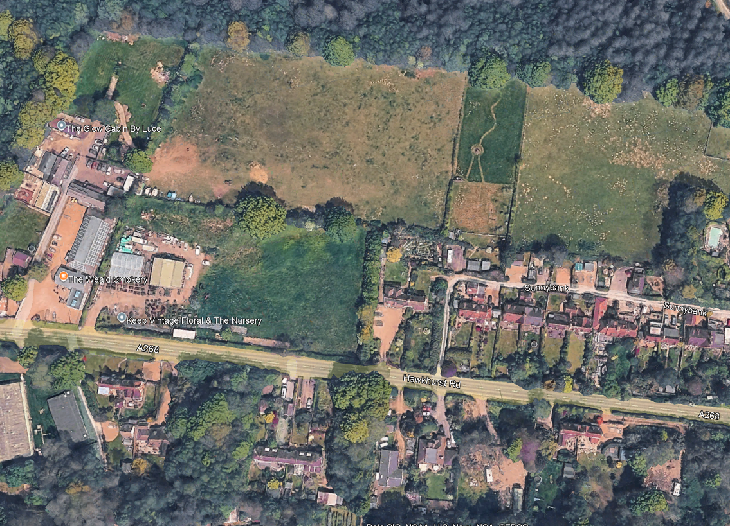  Greenfield site on edge of village. Submitted by landowner as part of the neighbourhood plan “call for sites” in December 2016.
Owner and contact | Frontage of the site is currently a smokery owned by Andrew Wickham and a newly opened garden nursery leased by Mr and Mrs John Wheble – it is understood that they have a three or five year lease on the land.  The land to the north might be in a number of peoples’ ownership. To be ascertained.  Land to rear of the Smokery and the Nursery is not known.
Amount of development | Density of housing is considered to be too heavy at 35 dwellings per hectare.
HELAA status | Was not in SHLAA now appearing in the current draft local plan.  Now being considered for 70 dwellings and community facility - Ticehurst Parish Council feels that the density of 35 dwellings per ha is too high. 30 to 35 dwellings, open space and community retail (grocery) outlet might be acceptable.
Planning policy | The site has been the subject of several planning applications from 2002 onwards. In 2013, an outline application (RR/2013/2094/P) for 11 houses (including four affordable) was refused on the grounds that it was outside the development boundary for Flimwell, therefore in open countryside, and would have a detrimental impact on the AONB.  Rother Core Strategy planning policies:  - EN6 (Flood Risk Management) and EN7 (Flood Risk and Development)  - LAN3 lighting – designed to comply with High Weald National Landscape Unit’s policies.  Ticehurst NP planning policies:  - R1 – Conserve Area of Outstanding Natural Beauty  - H1 – Spatial Plan  - H2 – Housing site allocation
Access | A new vehicular access would be required onto the busy A268 Flimwell to Hawkhurst road. The current access points are on the brow of the hill and increased traffic at this point would be dangerous.  Pedestrian access to Hawkhurst to the east and to Flimwell centre to the west, would need to be dramatically improved. The pavement to the south of Sunnybank properties is so narrow that it is dangerous.
Suitability | The site is mainly level, there are no rights of way and no utility features on the site.
Stream and Surface Water Flooding Issues | - No issues so compliant with Rother District CS policies EN6 (Flood Risk Management) and EN7 (Flood Risk and Development).  - In low flood risk Zone One.
Needs of rural village | - The site is outside the Flimwell development boundary (which is 350m away across the A21).  - The site is on the bus route between Ticehurst and Hawkhurst.  - The proposal would see the closure of two of the three retail outlets in Flimwell.  - There is a footpath to Flimwell cross-roads.  - The primary school and GP surgery at Ticehurst can only be reached by car or bus.  - The closest recreational facilities are at Flimwell crossroads, a 10-minute walk, but with the busy A21 to cross in order to reach them. The proposal is for an additional play area.  - There would be adequate car parking on site.
Heritage and Landscape impact | - There are no archaeological sites listed in the Ticehurst Parish historic environment report.  - There are several listed buildings nearby but the development would have little impact on them.  - Historic field boundaries should be retained.  - Biodiversity Report needed – applicant submitted a habitat survey.  - Ancient woodland to the north should have a strong 15 m buffer zone to protect it.  - The previous planning application determined that there would be a major impact on the AONB landscape
Assessment | Site is suitable | Uncertain
Assessment | Site is available | To be ascertained – likely there are several owners of this section of land.
Assessment | Site is achievable | Uncertain
Conclusions | There are two major problems with the site : it is a considerable distance from the Flimwell development boundary; and it would have a major impact on the AONB. An outline planning application for this site with less houses was refused in 2013, primarily for the above reasons.  Part of the site could be allocated?

Site 2
Address | Junction of London Road and A268 (North)
Site Area | 2.36 ha
Map | 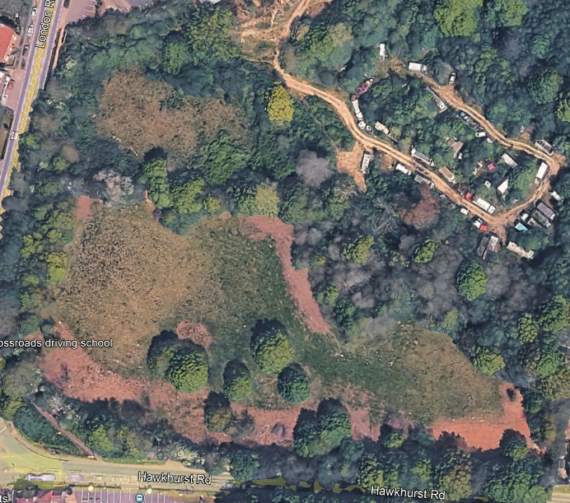  Green field site on the outskirts of Flimwell outside the Flimwell development area. Late submission of this land was sent in to the call for sites TNP 2016 but not considered.  It is understood that Quantum Homes have (or had) an option on the site. The plans to widen the A21 have often been mapped across the field and as such it could not be determined that the site is unachievable.
Owner and Contact | Group of owners - Bill Martin  Land is not registered to anyone – land registry details.
Amount of Development | Density of proposed housing is considered to be too high.  Environmental Impact Assessment has been carried out in February 2024 but this has not been seen.
HELAA status | Not considered in SHLAA but now considered suitable for residential and commercial i.e. mixed use.  Flimwell needs an affordable retail outlet.  Proposal is for 84 dwellings Ticehurst Parish Council does not feel that this density is acceptable in the AONB, with no decent transport links and that development should be limited to 30 – 35 dwellings  Some sporting facilities could be considered, including improved routes into Bedgebury Forest for pedestrians and cyclists.  Recent survey resulted in a desire for a pump track within the parish. However, to provide that facility, it would have to be conditional that safe access is provided.
Planning Policy | Rother Core Strategy planning policies:  - EN6 (Flood Risk Management) and EN7 (Flood Risk and Development)  - LAN3 lighting – designed to comply with High Weald National Landscape Unit’s policies.  - Proximity to ancient woodland and in AONB  Ticehurst NP planning policies:  - R1 – Conserve Area of Outstanding Natural Beauty  - H1 – Spatial Plan  H2 – Housing site allocation
Access | Gateway and dropped kerb on to the A268 would need to be altered due to poor sight lines on a fast road with brow of the hill to the east.
Suitability | Land slopes NE to SW - there was an historic right of way into Bedgebury along the boundary of site which could be improved, lessening the impact of cars parking along the A21.
Stream and Surface Water  Flooding issues | No issues apparent so compliant with RDC EN6 EN7 Low flood risk.
Needs of rural village | - Site has public transport passing on B2087/A268. There is a very restricted footpath on the main road passing the site to the A21.  - The site is outside Flimwell development boundary.  - Primary school and GP surgery would need to be accessed by car or bus. Village shops within 3km, 25 minutes’ walk.  - Playground and village hall within 5 minutes’ walk on western side of A21  - Site can deliver on-site parking.
Heritage and Landscape Impact | - Listed building on cross-roads on southern side of the A268  - No archaeological sites listed in parish historic environment report.  - In open countryside within High Weald AONB.  - Area has a lot of mature trees around the site that should be protected and retained.  - Historic field hedgerows should be protected and retained.
Assessment
  Site is suitable | For some development.
  Site is available | Yes
  Site is achievable | It might be
Conclusions | Part of the site could be allocated. However, this would prevent any improvements to the A21.

Site 3
Address | Land to the south of A268 Hawkhurst Road
Site Area | 3.94 acres
Map | 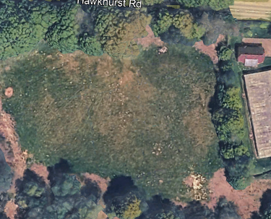
Owner and Contact | Group of owners - Bill Martin
Amount of Development | Density of proposed housing is considered to be too high.
HELAA  status | Not considered in SHLAA but now considered suitable in HELAA for residential and commercial i.e. mixed use.  Land has recently been cleared – access is reasonable  Environmental Impact Assessment was carried out in February 2024
Planning Policy | Rother Core Strategy planning policies:  - EN6 (Flood Risk Management) and EN7 (Flood Risk and Development)  - LAN3 lighting – designed to comply with High Weald National Landscape Unit’s policies.  - Policy Constraints - proximity to ancient woodland and in ANB.  Ticehurst NP planning policies:  - R1 – Conserve Area of Outstanding Natural Beauty  - H1 – Spatial Plan  H2 – Housing site allocation
Access | Gateway and dropped kerb on to the A268 would need to be altered due to poor sight lines on a fast road with brow of the hill to the east.  Thought would need to be given to the access points to the sites on the northern and southern areas of land to avoid creating a cross-roads, relatively near the A21 crossroads and encouraging heavy flows of traffic accessing the A268 in an already congested area queuing for the traffic lights.  Pedestrian access is poor and too narrow to the east and west of the site.
Suitability | Land is relatively flat.
Stream and Surface Water  Flooding issues | No issues apparent so compliant with RDC EN6 EN7 Low flood risk.
Needs of rural village | - Site has public transport passing on B2087/A268. There is a very restricted footpath on the main road passing the site to the A21.  - The site is outside Flimwell development boundary.  - Primary school and GP surgery would need to be accessed by car or bus. Village shops within 3km, 25 minutes’ walk.  - Playground and village hall within 5 minutes’ walk on western side of A21  - Site can deliver on-site parking.
Heritage and Landscape Impact | - Listed building on cross-roads on southern side of the A268  - No archaeological sites listed in parish historic environment report.  - In open countryside within High Weald AONB.  - Area has a lot of mature and veteran trees around the site that should be protected and retained.  - Historic field hedgerows should be protected and retained.  - Dark Skies policy AONB unit and Ticehurst Parish Council adopted policy would need to be included.
Assessment
  Site is suitable | For some development.
  Site is available | Yes
  Site is achievable | It might be
Conclusions | Part of the site could be allocated. However, this would prevent any improvements to the A21.

Site 4 FW1
Address | Land to rear of Fruitfields, High Street, Flimwell
Site Area | 2.3 ha of which 0.9 is considered for development
Map | 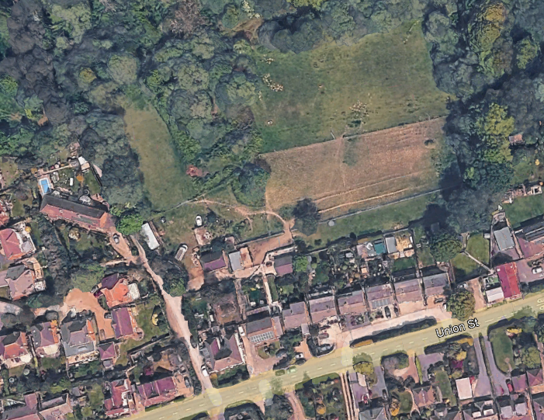
Owner and Contact | Peer Group own the majority Blue area was allocated in Ticehurst Neighbourhood Plan for 9 properties only.  It is understood that the area marked in orange is owned by another party who has stated in 2024 that she does not wish to sell her land. However, on checking land registry, the whole area appears to be in the name of Denbigh Properties Ltd (Peer Group) – contact being Amanda Birrane at the Hop Exchange.  The access track is owned by another party who would want to resist development.
Amount of Development | The HELAA has suggested 32 dwellings for the site with a density of 35 dwellings per hectare. It is felt that only the area in blue is considered suitable for 9 dwelling.
HELAA status | HELAA suggested 32 properties.
Planning Policy | No issues so compliant with RDC EN 6 and EN 7 Low flood risk.  Considered in Ticehurst Neighbourhood Plan as unsuitable for development other than for 9 properties.
Access | Currently poor, but the Wardsdown House proposal is to demolish to improve access to the site.
Suitability | Unsuitable - The low level Fruitfield properties to the south would be impacted upon, looking down over the area and any new properties would be afforded no privacy at all.
Stream and Surface Water  Flooding issues | No issues so compliant with RDC EN 6 and EN 7 Low flood risk.  Water run off from this land is heavy, heading north to Bewl Water and the Nature Reserve. Locals have reported on rare mosses and lichen in the area that have been recognised by botanists. (Chris Harrison – owner of the track to the west of the land.
Needs of rural village | The track is well used as a dog walking route through to Rosemary Lane.  Locals were very angry at the proposal during the Neighbourhood Planning consultations.
Heritage and Landscape Impact | Landscape impact would be detrimental to the extreme change in levels between Fruitfields to the south overlooking the whole area
Assessment
  Site is suitable | No
  Site is available | Yes
  Site is achievable | No
Conclusions | Site should not be allocated apart from the nine houses in the TNP.

Site 5
Address | Cedar Farm, Hastings Road, Flimwell
Site Area | 2.26 ha
Map | 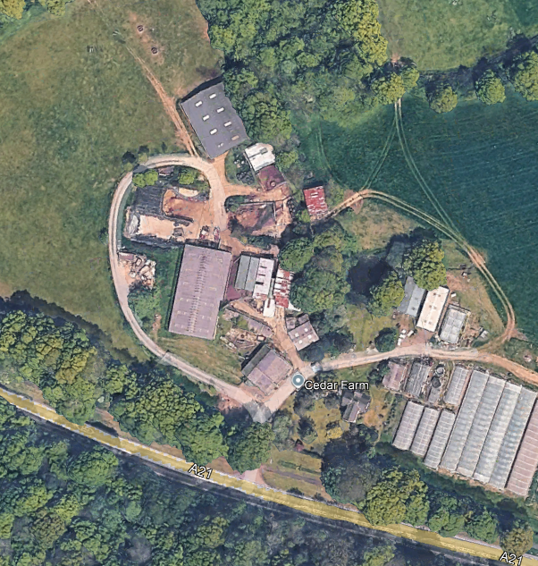
Owner and Contact | Malcolm and Colin Philips - family farm.
Amount of Development | 0.75 ha - employment development only.  15m buffer from the ancient woodland retention of pond and trees within the site.
HELAA status | Consideration for 0.75 ha suitable for development.
Planning Policy | Rother Core Strategy planning policies:  - EN6 (Flood Risk Management) and EN7 (Flood Risk and Development)  - LAN3 lighting – designed to comply with High Weald National Landscape Unit’s policies.  - Proximity to ancient woodland and in AONB  Ticehurst NP planning policies:  - R1 – Conserve Area of Outstanding Natural Beauty  - H1 – Spatial Plan
Access | Good access on to A21  No continuous pavement leading to Flimwell but there is pavement to Hurst Green to the south.
Suitability | Land appears to have drainage issues.
Stream and Surface Water  Flooding issues | Not known
Needs of rural village | Isolated position, but other farmsteads have diversified along the A21 into farm shops (Planters – Eggs to Apples).
Heritage and Landscape Impact | - There are no archaeological sites listed in the Ticehurst Parish historic environmental report
Assessment
  Site is suitable | Yes
  Site is available | Yes
  Site is achievable | Yes
Conclusions | Site could be allocated

Site 6
Address | Land at Cherry Tree Field TH1
Site Area | 1.43 ha
Map | 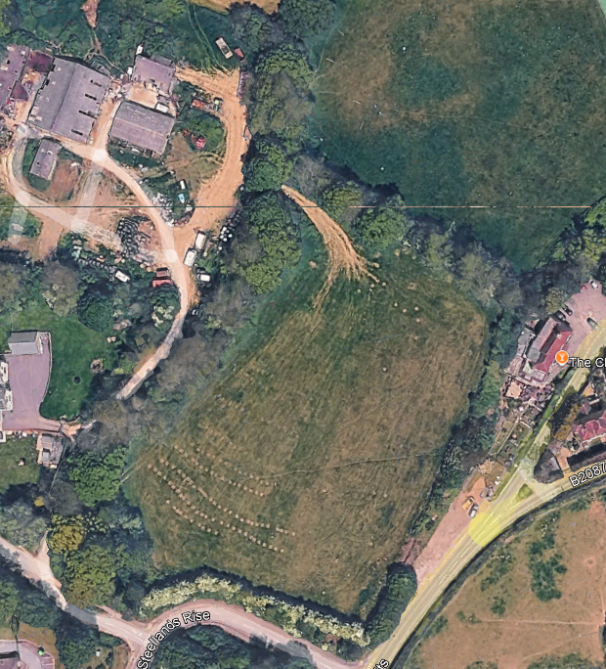  Considered as an exception site in the past.  Limitations due to the Bewl – Darwell water pipes around the edge of the site. Pipe line has now been ascertain and can be seen as an appendix. Roughly marked blue on the map above. Non-potable main.  Site is high and dominant in comparison with other properties in the area.
Owner and Contact | Stapleton-Smith family
Amount of Development | Limited due to pipe line - should be single storey in design
HELAA status | Considered in draft local plan for 30 dwellings per hectare on 0.5 ha = 15 properties - Ticehurst Parish Council feel that the density on this site is unsuitable and that a maximum of 10 would be suitable. The site sits higher than the roads and land around it, making it a dominant feature in the landscape. Design should be low level – such as at Singehurst.  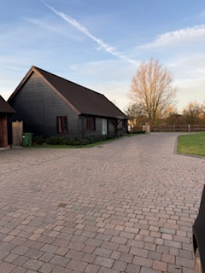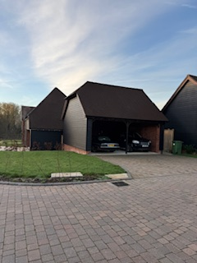  Low level buildings looking like a converted farm stead. There is demand in the village for this type of property – all sold off plan.
Planning Policy | Rother Core Strategy planning policies:  - EN6 (Flood Risk Management) and EN7 (Flood Risk and Development)  - LAN3 lighting – designed to comply with High Weald National Landscape Unit’s policies.  - Proximity to ancient woodland and in AONB  Ticehurst NP planning policies:  - R1 – Conserve Area of Outstanding Natural Beauty  - H1 – Spatial Plan  H2 – Housing site allocation
Access | Access would be steep
Suitability | Reducing dominance of the plot would be problematical
Stream and Surface Water  Flooding issues | No issues so compliant with RDC EN 6 and EN 7 Low flood risk.
Needs of rural village | - Site has public transport from nearby B2087 bus stop.  - There is a good footpath on the road passing the site to the village centre  - The site is outside Ticehurst development boundary.  - Primary school and GP surgery are within walking distance.  - Village shops within 15 minute walk  - Playground and village hall within 10 minutes walk  - Site can deliver on-site parking.
Heritage and Landscape Impact | Impact on landscape would be significant - planting and low level properties would minimise the impact.
Assessment
  Site is suitable | Yes
  Site is available | Yes
  Site is achievable | Yes
Conclusions | If allocated very limited single storey dwellings suitable – max 10

Site 07
Address | Land at Steelands Farm Ticehurst – northern field
Site Area | 2.46 ha
Map | 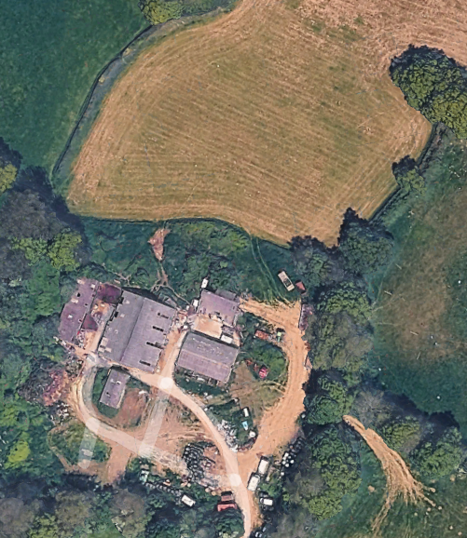Well screened site of old and unattractive farm buildings. It is believed that an application on the site has been refused in the past.
Owner and Contact | Stapleton-Smith family - TPC and owners have been in contact.
Amount of Development | This site was originally limited to footprint of the current buildings but has been assessed with further land to the north-east, doubling the size.  It does suggest that a pedestrianised route to Tinkers Lane is provided with the development which was an aim contained within Ticehurst Neighbourhood Plan and the owner confirmed that a more user-friendly path should lie to the south of the fields and starting by Coronation Cottages to ensure usage by residents.  Ticehurst PC would want to keep the two fields separate, with market low level housing on the southern site and then mixed market and affordable on the larger site to the north.
HELAA status | Recommending 1.3 ha of development area = 39 dwellings  Ticehurst Parish Council feels that the 30 dwellings per hectare proposed is too dense for the area and would support 25 dwellings with landscaped areas.
Planning Policy | Rother Core Strategy planning policies:  - EN6 (Flood Risk Management) and EN7 (Flood Risk and Development)  - LAN3 lighting – designed to comply with High Weald National Landscape Unit’s policies.  - Proximity to ancient woodland and in AONB  Ticehurst NP planning policies:  - R1 – Conserve Area of Outstanding Natural Beauty  - H1 – Spatial Plan  H2 – Housing site allocation
Access | Good
Suitability | Suitable for conversion to farm industrial site of small lets or demolition and dwellings designed as converted farm homestead.
Stream and Surface Water  Flooding issues | No issues  so compliant with RDC EN 6 and EN 7 Low flood risk.
Needs of rural village | - Site has public transport from nearby B2087 bus stop.  - There is a good footpath on the road passing the site to the village centre  - The site is outside Ticehurst development boundary.  - Primary school and GP surgery are within walking distance.  - Village shops within 15 minute walk  - Playground and village hall within 10 minutes walk  - Site can deliver on-site parking.
Heritage and Landscape Impact | There are no archaeological sites listed in the Ticehurst Parish historic environment report.
Assessment
  Site is suitable | Yes
  Site is available | Yes
  Site is achievable | Yes
Conclusions | If allocated by RDC best suited to limited farm stead dwellings – max 25

Site 08
Address | Orchard Farm, Ticehurst TH2
Site Area | 0.23 ha
Map | 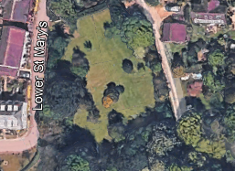
Owner and contact | Mr and Mrs Green
Amount of development | 5 dwellings
HELAA Status | Site allocated for 6 dwellings through Policy H2 of the Ticehurst Neighbourhood Plan 2019. Planning was granted for 5 dwellings in 2024. However, there is currently a planning application for two dwellings being considered for this site. HELAA states a density of 42 dwellings per ha on this site so 5 dwellings.
Planning Policy | Rother Core Strategy planning policies:  - EN6 (Flood Risk Management) and EN7 (Flood Risk and Development)  - LAN3 lighting – designed to comply with High Weald National Landscape Unit’s policies.  - Proximity to ancient woodland and in AONB  - ENV2 SUDS Rother Local Plan  Ticehurst NP planning policies:  - R1 – Conserve Area of Outstanding Natural Beauty  - H1 – Spatial Plan  H2 – Housing site allocation HOU2 Rother Local Plan
Access | Access is difficult, either off the private track leading to Orchard House or from Lower St. Mary’s where access would need to go across the marked gully.
Suitability | Suitable once, the sewerage issue is solved.
Stream and Surface Water Flooding Issues | Western area is at risk of flooding and Southern Water are currently looking at the area as raw sewerage is spilling into the area when there is heavy rain fall. Almost half the site is vulnerable to surface water flooding, particularly the northwest of the site.
Needs of rural village | - Site has public transport from nearby B2087 bus stop.  - There is a good footpath on the road passing the site to the village centre.  - The site is within Ticehurst development boundary.  - Primary school and GP surgery are within walking distance.  - Village shops within 10 minute walk  - Playground and village hall within 5 minutes walk  Site can deliver on-site parking.
Heritage and Landscape Impact | Little impact, screened boundaries, and additional planting, could provide privacy for this small site.
Assessment
  Site is Suitable | Yes if sewerage is sorted
  Site is Available | Yes
  Site is Achievable | Yes with condition above
Conclusions | Site is suitable for a very small number of dwellings once the sewerage issue has been resolved.

Site 09
Address | Land at Lymden Lane, Stonegate TIC0079
Site Area | 0.12 ha
Map | 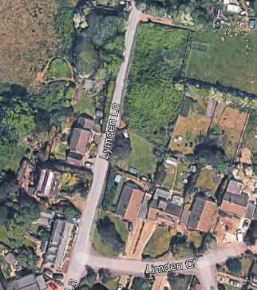
Owner and contact | Mr Smith - to be confirmed
Amount of development | 0.12 ha for 5 dwellings
HELAA Status | HELAA suggesting row of 5 terraced houses with vehicular and pedestrian access from Lymden Lane and an area for-on site turning.  Ticehurst Parish Council would want to see off-road parking for 1.5 cars per property – if that can not be provided, the number of dwellings should be reduced to enable this design.
Planning Policy | Rother HOU2 Rother Local Plan for on-site affordable housing.  Rother Core Strategy planning policies:  - EN6 (Flood Risk Management) and EN7 (Flood Risk and Development)  - LAN3 lighting – designed to comply with High Weald National Landscape Unit’s policies.  - Proximity to ancient woodland and in AONB  - ENV2 SUDS Rother Local Plan  Ticehurst NP planning policies:  - R1 – Conserve Area of Outstanding Natural Beauty  - H1 – Spatial Plan  H2 – Housing site allocation HOU2 Rother Local Plan
Access | Access on and off Lymden Lane is dangerous. It is very often used as a diversion route with a lot of traffic and poor sight-lines. There is no pavement to the village.
Suitability | It is suitable, so long as it is safe
Stream and Surface Water Flooding Issues | No known, but not felt to be an issue.
Needs of rural village | Stonegate has a primary school within walking distance and a village hall and playground within walking distance. There is no pavement to access these facilities and the local church.  Use of a car would be essential to live in this location, so not in keeping with Green to the Core - Rother policies.
Heritage and Landscape Impact | Impact on the landscape would be low and design should be mirroring the small terraced row of cottages to the west of Lymden Lane at the junction to blend into the landscape.
Assessment
  Site is Suitable | Yes
  Site is Available | Unknown
  Site is Achievable | Yes
Conclusions | Site is suitable as long as entering and leaving the site have acceptable highways sight-lines.

Site 10
Address | Land east of Bardown Road, Stonegate TIC0035
Site Area | 1.25 ha of which 0.63 ha is suggested for the development of 20 houses.
Map | 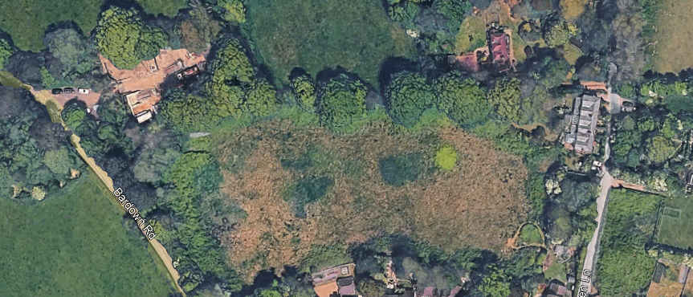
Owner and contact | Unknown, no title on land registry. No planning history, categorised as agricultural land. Footpath (24 or 34) appears to run through the northern part of the field. Land registry states that there is a UKPN substation nearby.
Amount of development | Considered for 20 properties including affordable.
HELAA Status | New site, currently unknown if the owners put the site forward in Rother’s call for sites.  Ticehurst Parish Council consider the proposed density to be too high and a maximum of 10 dwellings should be considered.
Planning Policy | Rother Core Strategy planning policies:  - EN6 (Flood Risk Management) and EN7 (Flood Risk and Development)  - LAN3 lighting – designed to comply with High Weald National Landscape Unit’s policies.  - Proximity to ancient woodland and in AONB  - ENV2 SUDS Rother Local Plan  - Ancient Woodland - northern boundary  - Source Protection Zone (SPZ3) in north west corner - wide area around a water abstraction point - that could affect other properties.  Ticehurst NP planning policies:  - R1 – Conserve Area of Outstanding Natural Beauty  - H1 – Spatial Plan  H2 – Housing site allocation HOU2 Rother Local Plan for affordable homes.
Access | Bardown Road is a fast road, which is currently an issue in the parish and investment to reduce the speed of traffic approaching the primary school is being undertaken.
Suitability | Suitable but not at the density of 35 dwellings per ha.
Stream and Surface Water Flooding Issues | Not known  - Source Protection Zone (SPZ3) in north west corner - wide area around a water abstraction point - that could affect other properties.
Needs of rural village | Stonegate has a primary school within walking distance and a village hall and playground within walking distance. There is no pavement to access these facilities and the local church.  Use of a car would be essential to live in this location, so not in keeping with Green to the Core - Rother policies.  Safer pedestrian route to the village should be provided.
Heritage and Landscape Impact | The area is high - the drop down from the field to Lymden Lane is significant so design of any development should be low level – such as at Singehurst. The topography of the site would have a dramatic and detrimental effect on some of the properties within the Acorns as well as the impact on the wider landscape. The roof tops would be very visible from the west. There is a large archaeological notification area associated with Bardown Farm, some 300m to the north, so an archaeological survey would be necessary. Acorns, immediately to the south of the site, and only slightly smaller, was considered for 6 dwellings that have blended in well to the village. The size of the proposed development is disproportionate to the size of the village which has few facilities. There is no pavement on Bardown road to access the school and there are already grave concerns about pedestrian safety at the junctions with Lymden Lane and Cottenden Road.
Assessment
  Site is Suitable | Partially
  Site is Available | Unknown
  Site is Achievable | Probably
Conclusions | Suitable for a small development such as Acorns. Introducing more traffic on to the fast Bardown Road is a major concern.

