Rother District Council
Via email draftlocalplan@rother.gov.uk
18th March 2026
Dear Planning Policy Team
RE: Rother DC Local Plan consultation January to March 2026
I am responding to this consultation on behalf of the British Horse Society, the UK’s largest equestrian charity with over 125,000 members and representing the country’s 3.2 million horse riders.
We ask that you include horse riders (and carriage drivers wherever possible) in your plan. The evidence base for this request is at Appendix 1. We urge you to read this information to understand the real benefits to the District of equestrian inclusion in the Local Plan. The nature of our response is that it does not lend itself to the online questions within the Plan.
Opportunities for equestrian inclusion within the Rother District Local Plan
Active travel is defined by Transport for South East thus, “Active travel refers to walking, wheeling (e.g. mobility aids, children in prams), cycling, scooting and horse-riding.”
We would ask that RDC adopts a similar definition and includes horse riders within their Active Travel proposals within the Plan unless there are cogent unresolvable reasons for not doing so.
Wherever walking/cycling proposals or policies are mentioned, this should be extended to include equestrians too. The assumption should be one of inclusion not exclusion.
Where development requires the inclusion of provision for non motorised users, this must include walking, cycling and horse riding as a minimum. Where space allows this should also include carriage driving.
Specific areas of the documents which we wish to comment on are below.
2. Vision, Overall Priorities and Strategic Objectives
2.2. The Local Plan sets out twin overall priorities (Green to the Core and Live Well Locally) to meet that vision, which are important to the overall delivery of the plan, along with key strategic objectives that the plan seeks to deliver. These lead to the creation of the Local Plan’s Development Strategy for both the whole district and five sub-areas within it, and ultimately, provide the framework for meeting identified development needs.

The inclusion of equestrians within all walking/cycling/leisure parts of the plan will help with the Plan’s twin overall priorities, provide better value for money for the tax payer AND benefit the local economy (see Appendix 1 below)

Strategic Spatial Objectives
1. Mitigate and adapt to climate change, including by delivering net zero carbon ambitions, reducing flood risk from all sources and promoting the multifunctional benefits of green blue infrastructure through effective and supportive planning policies.
3. Promote high quality, inclusive design and protect and enhance the significance of Rother’s built and natural heritage, including its setting, while providing opportunities for recreation and tourism.
6. Create economic prosperity, both in rural and urban locations, meeting the employment needs of the wider population and local businesses, improving the quality and variety of jobs, and being flexible to the changing needs of the economy.
8. Enhance the sustainability and connectivity of local communities through sustainable transport measures, including to support active travel, and improved internet network coverage.
9. Support and achieve safe, healthy, vibrant and mixed communities where the physical and mental health and well-being of residents is a high priority. Create high standards of inclusivity and accessibility to shared facilities for all the district’s residents.

See comment above.

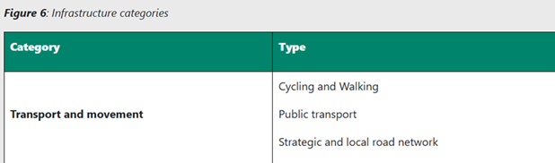
Transport and movement must include ALL legitimate road users, especially vulnerable road users, which includes horse riders and carriage drivers

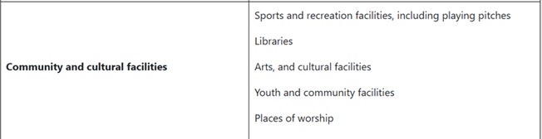
Sports & recreational facilities need to allow for riding schools and livery yards and, in areas where the demand is highest, community riding manèges

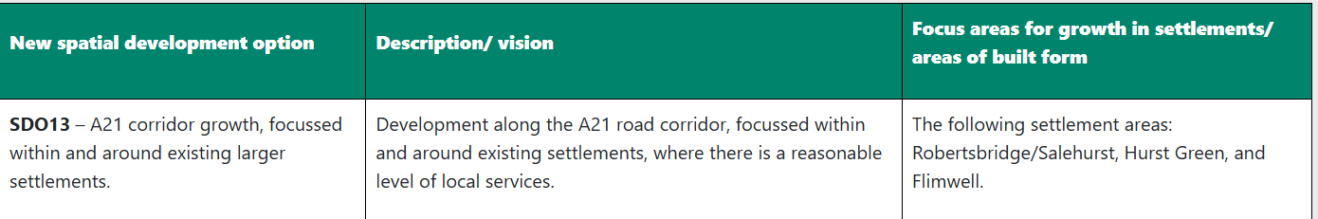

Road side development, such as that proposed above, should ensure the inclusion of “behind the hedge” paths to enable connectivity to surrounding public rights of way and quieter lanes. Many quiet lanes and PROW are disconnected by roads such as the A21 and reconnecting them would encourage more, safe walking, cycling, horse riding and even carriage driving.
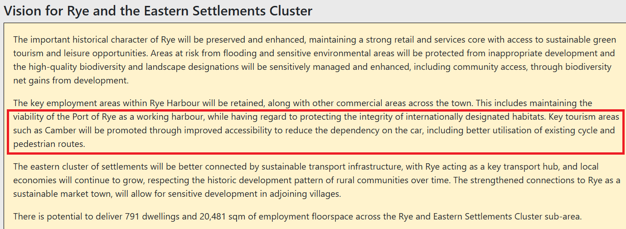

Any further improvements for walking and cycling in this area must include equestrians too. The reasons for inclusion are set out in appendix 1 below.

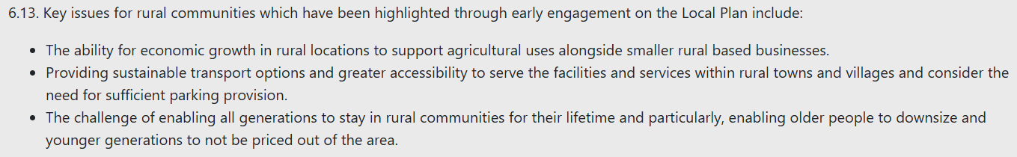
Rural communities include equestrians. Additional pressures on riding schools and livery yards mean that they need to be included alongside the support for “smaller rural based businesses”.

Northern Rother

Equestrianism is the second largest rural employer and so must be supported alongside other rural businesses.
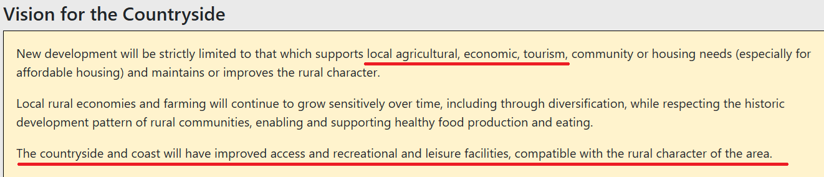

Equestrianism is the second largest rural employer and so must be supported alongside other rural businesses. Equestrian tourism also flourishes where good off road riding is available and (for day trips) good safe horsebox parking. Equestrian recreational and leisure facilities must therefore also be included.

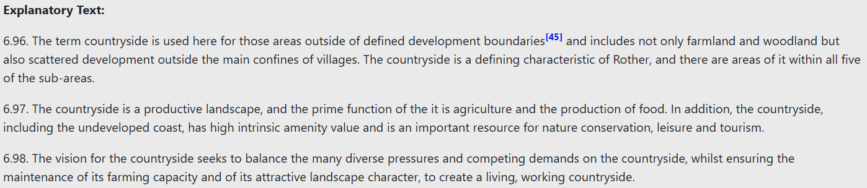

See comments above
Further 6.97 merely scatches the surface of the use of the countryside - forestry, horticulture and equestrianism feature strongly across Rother DC’s landscape and are equally worthy of protection and promotion.

As previously requested above, we urge the Council to read the information contained within Appendix 1 below which explains why the inclusion of equestrians is beneficial to everyone.
As always we would welcome the opportunity to work with the Council and, indeed, future developers to ensure the inclusion of equestrians in their plans.
Yours faithfully

Sarah Rayfield (Mrs.)
Access Field Officer – London & South East

Appendix 1
Factors to consider in decision making around equestrian inclusion
Economic Value
There are almost 19,000 horses passported to owners living in Kent, the contribution for which to the economy is over £128 million per annum, much of it likely to be spent locally (vets, farriers, feed merchants, hay and bedding suppliers, etc.)
The outdoor recreation ‘sector’ is worth £22 billion to the UK economy annually with £5 billion of that coming from the horse industry.
Equestrianism is the second largest rural employer after agriculture.
Social Value
Recent studies have demonstrated the social value of horses to be £1.2 billion
Safety
Statistics collated for 2025 by British Horse Society indicate that
- 2,810 road incidents involving horses have been logged with British Horse Society
- 59 horses have died, and 82 have been injured
- 86 people have been injured
- 22% of riders were victims to road rage or abuse
- 78% of incidents occurred because a driver passed by too closely to the horse
- 83% of incidents occurred because a driver passed by too quickly
The % of those passing too quickly has risen from 81% in 2024 to 83% in 2025 — this is the highest percentage recorded since 2017.
These figures are significantly lower than the real situation as NHS statistics indicate that in the year 2023/2024 there were 2493 admissions for “Animal-rider or occupant of animal-drawn vehicle injured in transport accident”
Gender Split
Sport England: Adult
- 88% regular riders are female, 81% of occasional riders are female
- 16–24-year-olds have the highest rate of participation, but rates remain consistent by age up to 65+
- The highest participation rates are seen amongst those with mental health challenges
Health & Wellbeing
A new piece of work released by British Equestrian (BE) is directly aligned with the government’s Get Active: A strategy for the future of sport and physical activity document, which calls for sport and physical activity to support public health, tackle inequality and boost community resilience.
BE’s research supports this vision by providing robust monetised evidence of how equestrianism contributes to:
- Preventative healthcare and reduced NHS demand
- Inclusive access for women, older adults, disabled people and underserved communities
- Community wellbeing through volunteering and engagement
- Cross-sector integration with health, education and care.
Equestrianism is ideally positioned to be part of the Government’s sport and physical activity ambitions, as it is an industry with already measurable impact and additional untapped potential.
People with a physical disability are able to undertake horse riding and associated activities at the same self-reported level of frequency and physical intensity as those without such an illness or disability., a fact which is quite unique amongst other sports.
As a result of being involved with horses, Riding for the Disabled Association (RDA) reports
- 90% of participants feel more confident in themselves
- 82% feel more connected to others
- 72% are better able to regulate their emotions
- 71% have improved their motor skills.
Equestrian activity is recognised by available literature as a contributor to personal growth and development, especially among young people. Reported outcomes include increased self-esteem, confidence, improved behaviour, and stronger social skills. Equine-assisted learning and therapeutic programs also show positive effects on job readiness and employability—particularly among marginalised groups and individuals with mental health challenges.

The Impact of Active Travel Plans and LTN 1/20 on Equestrians
A Summary of the Issues is provided on this link https://www.bhs.org.uk/media/qlxjdf3r/202505-summary-of-the-impact-of-active-travel-plans-and-ltn-120-on-equestrians-british-horse-society.pdf

National Planning Policy Framework
96. Planning policies and decisions should aim to achieve healthy, inclusive and safe places which:
c) enable and support healthy lives, through both promoting good health and preventing ill-health, especially where this would address identified local health and well-being needs and reduce health inequalities between the most and least deprived communities […]
105. Planning policies and decisions should protect and enhance public rights of way and access, including taking opportunities to provide better facilities for users, […]
125. Planning policies and decisions should:
a) encourage multiple benefits from both urban and rural land, including through mixed use schemes and taking opportunities to achieve net environmental gains – such as developments that would enable new habitat creation or improve public access to the countryside;
DEFRA Circular 1/09 Rights of Way
7.1 Proposals for the development of land affecting public rights of way give ride to two matters of particular concern: the need for adequate consideration of the rights of way before the decision on the planning application is taken…
7.2 The effect of development on a public rights of way is a material consideration in the determination of applications for planning permission and local planning authorities should ensure that the potential consequences are taken into account whenever such applications are considered.

DEFRA FoI December 2024
BETA 2023
https://www.britishequestrian.org.uk/assets/INSIGHT/251008%20BEF%20The%20Power%20of%20Horses%20FINAL%20HIRES.pdf
The Power of Horses: Equestrianism’s Social Value October 2025
https://digital.nhs.uk/data-and-information/publications/statistical/hospital-admitted-patient-care-activity/2023-24#
https://www.britishequestrian.org.uk/assets/EXTRA_Docs/Short%20State%20of%20the%20Nation.pdf
The Power of Horses: Equestrianism’s Social Value October 2025
https://www.bhs.org.uk/media/gannghxh/health-benefits-of-riding-in-the-uk-full-report.pdf
https://rda.org.uk/impact/
https://www.gov.uk/government/publications/rights-of-way-circular-1-09

